Challenge Description:-
"Our SIEM detected an unusual heartbeat from the secure vault. No high ports were open, and no data-transfer protocols were active. Yet, the bandwidth was slowly bleeding. We've captured the noise. Analyze the "heartbeat" and find the stolen sequence hidden in the rhythm of the network."

We are provided with a PCAP network capture and need to determine how data was covertly exfiltrated from the system.

1. Initial analysis:-
The first step was to open the provided PCAP file using Wireshark to observe the captured network traffic.
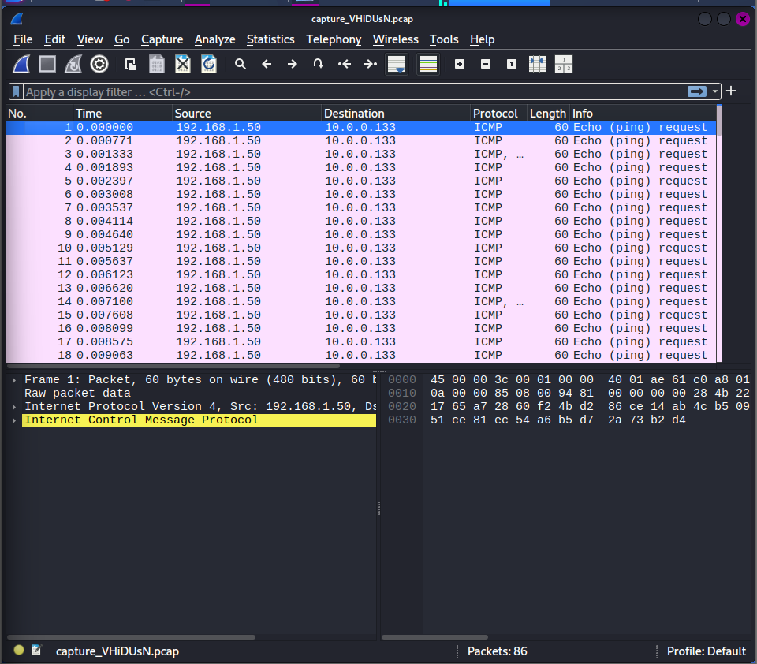

Most of the traffic consisted of ICMP Echo Request packets (ping traffic).

2. Inspecting ICMP traffic:-
Lets apply the filter “icmp” in wireshark. A closer look at the ICMP packet details revealed that some packets contained ASCII text inside the payload section.

3. Investigating the payload:-
Pattern 1: noise packets.
data_chunk_7

something like this. Seems like noise/decoy.

Pattern 2: structured data packets
SEQ: 48291 | DATA: C
The presence of single characters strongly suggested that the hidden message was being transmitted one character per packet.

After reviewing the packet capture more carefully, it becomes clear that:
- The sequence numbers are intentionally random
- They are used only to mislead
The correct order of characters seems to be simply the packet arrival order within the capture.

4. Extracting the Hidden Message:
By reading the characters stored in each DATA: field in the order the packets appear, the hidden message can be reconstructed.

Combining these characters result in the flag.
Flag:- CIPH{ICMP_EXFILTRATION_PING}

